Ideation Phase

Brainstorm & Idea Prioritization Template

|  |  |
| --- | --- |
| Date | 19 September 2022 |
| Team ID | PNT2022TMID31946 |
| Project Name | Smart lender applicant credibility prediction for loan approval |
| Maximum Marks | 4 Marks |

# Brainstorm & Idea Prioritization Template:

Deal with the problem, we developed automatic loan prediction using machine

• Time period for loan sanctioning will be reduced.

• Whole process will be automated , so human error will be avoided

• Eligible applicant will be sanctioned loan without any delay.

• Time period for loan sanctioning will be reduced.

• Whole process will be automated , so human error will be avoided

• Eligible applicant will be sanctioned loan without any delay.

• Time period for loan sanctioning will be reduced.

• Whole process will be automated , so human error will be avoided

• Eligible applicant will be sanctioned loan without any delay.

• Time period for loan sanctioning will be reduced.

• Whole process will be automated , so human error will be avoided

• Eligible applicant will be sanctioned loan without any delay.

To learning techniques. We will train the machine with previous dataset. so machine can analyse and understand the process . Then machine will check for eligible applicant and give us result.

Advantages:

1. Time period for loan sanctioning will be reduced.

2. • Whole process will be automated , so human error will be avoided

• Whole process will be automated , so human error will be avoided

• Whole process will be automated , so human error will be avoided

2. Whole process will be automated , so human error will be avoided

3. Eligible applicant will be sanctioned loan without any delay

• Time period for loan sanctioning will be reduced.

• Whole process will be automated , so human error will be avoided

• Eligible applicant will be sanctioned loan without any delay.

Reference:

1. Kumar Arun, Garg Ishan, Kaur Sanmeet, May-Jun. 2016. Loan Approval Prediction based on Machine Learning Approach, IOSR Journal of Computer Engineering (IOSR-JCE)

2. Wei Li, Shuai Ding, Yi Chen, and Shanlin Yang, Heterogeneous Ensemble for Default Prediction of Peer-to-Peer Lending in China, Key Laboratory of Process Optimization and Intelligent Decision-Making, Ministry of Education, Hefei University of Technology, Hefei 2009, China

# Step-1: Team Gathering, Collaboration and Select the Problem Statement

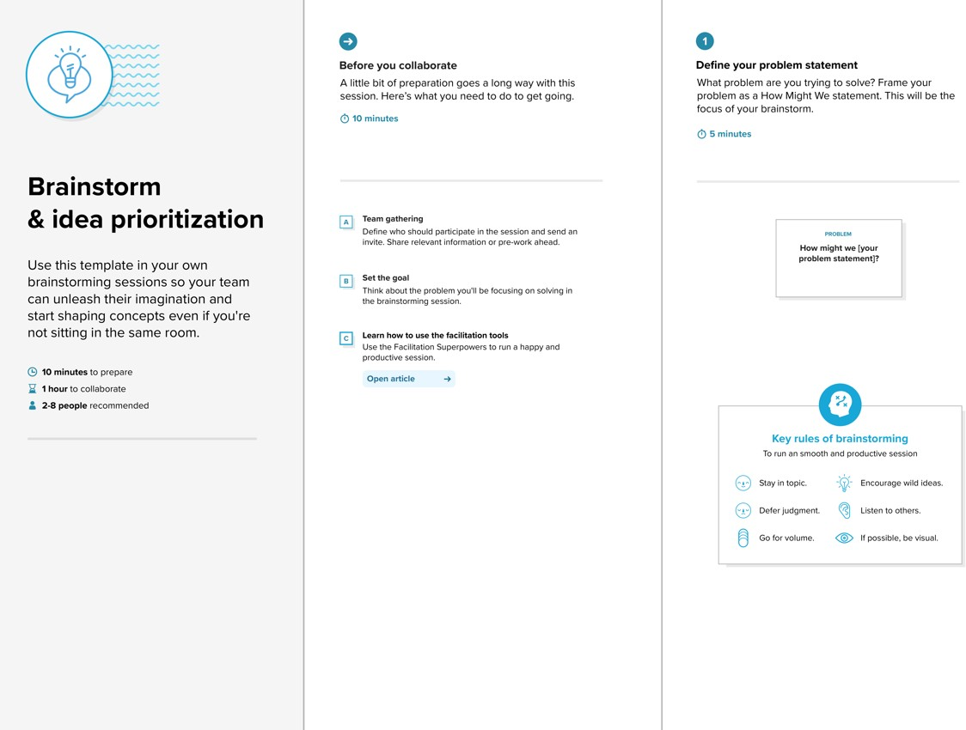

**Step-2: Brainstorm, Idea Listing and Grouping**

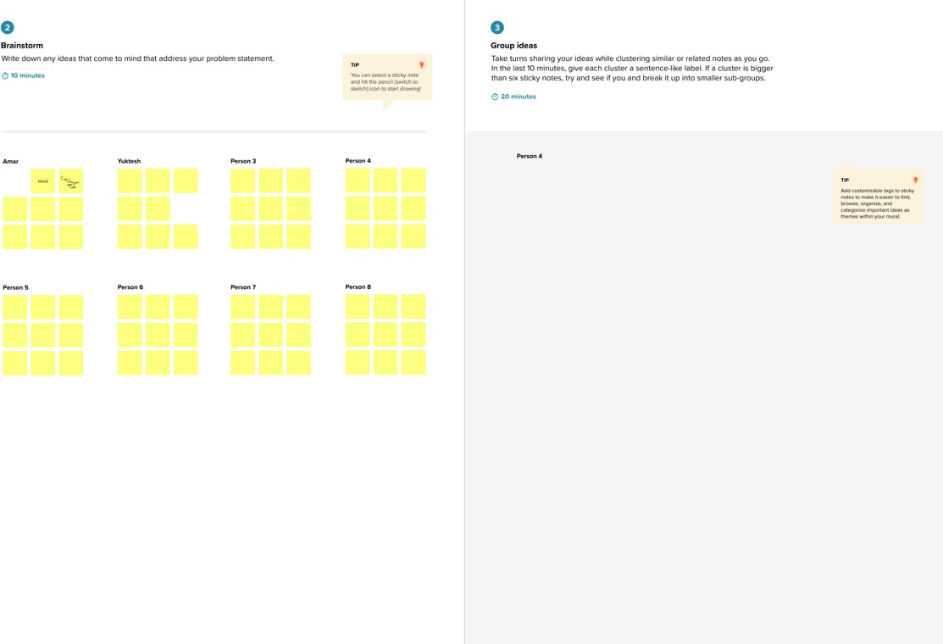

**Step-3: Idea Prioritization**

